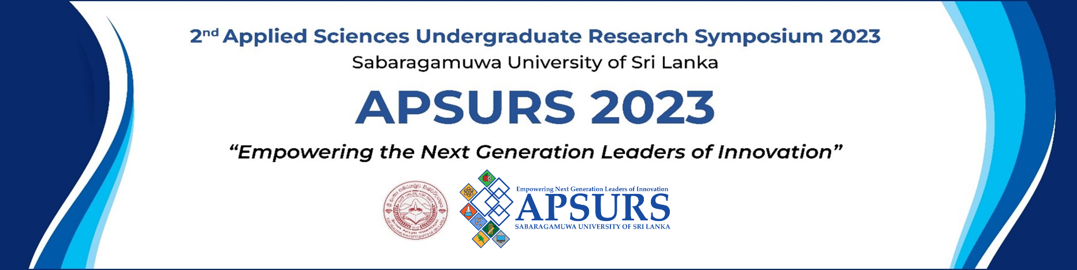

Application Form - Pitch Competition
Personal Details

Full Name of the Main Contact Person:
University/ Institute:
Year of Study:
Student Registration Number:
Email:
Contact Phone Number :
Project Title / Business Title :
Name of Supervisor / Principal Investigator :
Project/ Business Details

- Describe your innovation/business idea briefly.(Max. 150 Words) [You can use images and graphs]
__________________________________________________________________________________________________________________________________________________________________________________________________________________________________________________________________________________________________________________________________________________________________________________________________________________________________________________________________________________________________________________________________________________________________________________________________________________________________________________________________________________________________________________________________________________________________________________________________________________________________________________________________________________________________________________________________________________________________________________
- Commercial value of your invention (Max. 100 Words)
__________________________________________________________________________________________________________________________________________________________________________________________________________________________________________________________________________________________________________________________________________________________________________________________________________________________________________________________________________________________________________________________________________________________________________________________________________________________________________________________________________________________________________________________________________________________________________________________________________________________________________________________________________________________________________________________________________________________________________________

- Strategic location of your business and reason (Max. 50 Words)
__________________________________________________________________________________________________________________________________________________________________________________________________________________________________________________________________________________________________________________________________________________________________________________________________________________________________________________________________________________________________________________________________________________________________________________________________________________________________________________________________________________________________________________________________________________________________________________________________________________________________________________________________________________________________________________________________________________________________________________
- What is your target market/customers? (Max. 50 Words)
__________________________________________________________________________________________________________________________________________________________________________________________________________________________________________________________________________________________________________________________________________________________________________________________________________________________________________________________________________________________________________________________________________________________________________________________________________________________________________________________________________________________________________________________________________________________________________________________________________________________________________________________________________________________________________________________________________________________________________________

- How will your business benefit the community? (Max. 100 Words)
__________________________________________________________________________________________________________________________________________________________________________________________________________________________________________________________________________________________________________________________________________________________________________________________________________________________________________________________________________________________________________________________________________________________________________________________________________________________________________________________________________________________________________________________________________________________________________________________________________________________________________________________________________________________________________________________________________________________________________________
- Analysis of market competition (Max. 75 Words)
__________________________________________________________________________________________________________________________________________________________________________________________________________________________________________________________________________________________________________________________________________________________________________________________________________________________________________________________________________________________________________________________________________________________________________________________________________________________________________________________________________________________________________________________________________________________________________________________________________________________________________________________________________________________________________________________________________________________________________________

- Revenue break-down (i.e., cash flow) for next five years (Optional) (Max. 100 Words)
__________________________________________________________________________________________________________________________________________________________________________________________________________________________________________________________________________________________________________________________________________________________________________________________________________________________________________________________________________________________________________________________________________________________________________________________________________________________________________________________________________________________________________________________________________________________________________________________________________________________________________________________________________________________________________________________________________________________________________________
If you are participating as a team fill the team details
Team Details
TEAM MEMBER 1
First name / Last name / Title
Provide your title (e.g. "CEO", "Founder",” team member “)
Year of study :
Student Registration number :
Email:

TEAM MEMBER 2
First name / Last name / Title
Provide your title (e.g. "CEO", "Founder", team member “)
Year of study :
Student Registration number :
Email:

TEAM MEMBER 3
First name / Last name / Title
Provide your title (e.g. "CEO", "Founder", team member “)
Year of study :
Student Registration number :
Email:

I have read the terms and conditions and by submitting the application & I agree to the terms and conditions.

_________________ _____________________
Date Signature/s

